10th Xitucheng Street
Haidian district, Beijing100876
(010)6228-2222

June 5, 2015

Ms. Manshu Wang
Beijing university of posts and telecommunications
Communication engineering and management
2013213127

LABORATORY REPORT
Technologies Behind PC Games
And Its Future Development, BUPT

INTRODUCTORY SUMMARY
PC games nowadays have already become a main component for people to relax themselves in their daily life. Yet, with the constantly development of PC technologies, the future PC game evoke my interesting. Then, I see a movie called the Ender’s Game, from which the magic game used for training commander and assessing the mentality impresses me very much. So, I want to anticipate what the future PC games will like both in hardware and software. After query, I foresee that the game engine and the AI system maybe changes a lot, and more advanced device like VR glass will add to the peripherals family.

LAB MATERIALS
Our lab analysis relies on only four pieces of specialized equipment; game engine, artificial intelligence, VR Head-Mounted display, Emotive Epoc. We simply combine these together and make a virtual 4D feeling than normal PC games. Other equipment is similar to that included in any basic geology lab, such as filtering screen and burners.

LAB PROCEDURE
Once we receive a sample, we first try to identify the need of customers and exact kinds of game we need to design. Our specific lab procedure for your samples consisted of these for steps:

Step1:
Game Engine is a series of well-compiled and editable PC game system or a core component of many interactive image application. Since 1992 when the first generation of Game Engine was born, such technology changes a lot and now, the Game Engine becomes a complex system consisting of various of subsystems, include modeling, cartoon, particle effect and other tools which almost cover all key segments of programming.
Game Engine is the basis of PC games, the quality of game is straightly decided by whether the engine is good or not. After evaluate the benefit of new engine concept promoted by those advanced engine development companies shown in Fig.1, I find some common improvements that the future engine would develop. That is, future engine would
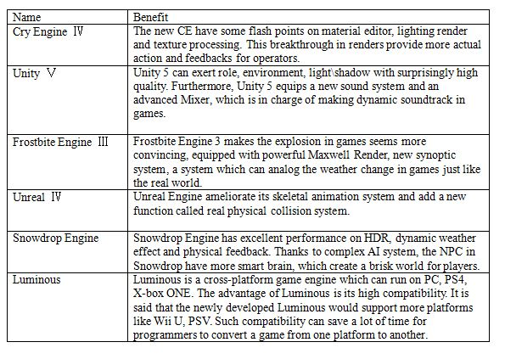
Figure 1 Benefit of the Nex-Gen Game Engine

Primarily focus on strengthening the exaggeration of light/shadow, the appearance of the material, the quality of sound. Additionally, the compatibility of engine may also be a popular trend during the reformation of engines.

Step2:
Perceptual Input System is used to gather useful information from the surroundings. Memory Control System is a subsystem which can store those data collected by PIS with a proper way. Reasoning System is the core of the entire AI System, which analyzes those data obtained before and compared the result with the information stored in the memory and then make a logical decision and sequencing those strategies with great clarity. Decision-making Behavior System is in charge of telling the game character what the best strategies is and how to perform.

In PC games, technologies that mentioned before are utilized more or less. Furthermore, FSM and Decision Tree technology almost emerge in almost all games and gain great success. However, as time went by, nerve net and genetic algorithm those who are still immature now can become alternative skills of Decision Tree in the near future because those callow techniques have more powerful and wider applications in PC games compared with existing AI.

Step3:
Users with VR glass can see the monitor of PC with stereo perception by calculating the distance between the eyes. Moreover, with the help of inertial sensor like gyroscope and velograph, VR glass can swift the visual angle according to the position of the user’s head so that the user is fully enjoy the charm of the virtual world. Additionally, the installation of VR is quite easy, all it need is to insert the USB interference into the computer without any extra drive.

To fit all kind of users, the VR glass have three types of lens called Cup A, Cup B and Cup C whose focal distance is designed for short-sighted, normal-sighted and long-sighted respectively.[6] Nowadays, Sony, Microsoft and Oculus Rift all promote their own VR device. However, when user uses this glass for a long time, some side-effect like dizzy or headache will emerge.

Step4:
Emotive Epoc, mainly thanks to Electroencephalograph(EEG), a technology which sensing and learning signals from neurons, analyze them and translate those signals into message that machine can understand, finally, the computer repeat the action after the message is transmitted to PC, is a special cap with lots of electrode on it so that when user put this special hat on, he or she can operate the computer without touching the keyboard or mouse. That is to say, users can control the device with their own will and thought only. This device has already been produced by Emotive Systems Company.

CONCLUSION
After analyzing the data I collect from the questionnaire, then I find that nearly 60% of the interviewee agree that there a great change would happen on PC game hardwares and almost 80% of the people cites that it is the quality of the image that they think highly of most. So, such illustration, corresponding with the information I collected from webs, I make an anticipation towards the next generation of PC games.

A. Hardware
There is no doubt that with the improvement of the hardware techniques, Emotiv Epoc and VR Head-mounted Display will become the next two important peripherals of PC games following by keyboard, mouse and earphone because these devices contribute a great deal on enhancing the effect and operability, and these devices is simple-installed because they can exchange data with PC with USB rather than a series of tough operations. Furthermore, I can even foresee that 4D PC games will come into our life in the future comparing to the development of 4D movies, during which players can have different feelings corresponding with the plot. For example, you will be shocked by a tiny stream of electricity when the solider you controlled is injured.

B. Software
The change in software will not as obvious as that in hardware, but such reformation have greater influence on future PC games than hardware because it is software that exactly affects the quality of PC games most. I believe that in the near future, majorities of PC games will update their game engines and improve their AI system with advanced algorithm, for example, genetic algorithm can make the machine clearer than today but this theorem is still under testing and need more experiment to proof. What’s more, with the trend of engine compatibility, we can play more kinds of PC games which we can only play on other platforms before like Gears of War, a game which can only run on the X-BOX.

Thus there are nearly 80% of the people favors FPS games, so, it would be in FPS games that these technical breakthroughs would probably come into service. Whatever, from those thrilling changes we can see that, the PC games will meet all players whose appearance have already totally changed, with clearer image quality, smarter NPC, more real virtual environment, more detailed models and performances and definitely, with better feeling it can bring to us.

I will call you this week to arrange a time to discuss our study and any possible follow up you may wish us to improve.

Sincerely yours,

Manshu Wang
Student of BUPT

